P. Mallett Esq
Portman Building Society
Portman House
Richmond Hill
Bournemouth

BH2 6EP
Direct line:+44 20 7007 2611
Direct fax: + 44 20 7303 4048

Email: ayaacob@deloitte.co.uk

30 March 2007

Our ref: Ainol Yaacob/P11D2006-2007/7WS/LK

Dear Peter,

P11D Benefits in Kind Software – Final Release 2006/2007 - P11D Standard
Updated Licence Key: P11DD-847B3-78T43-73476

I am very sorry but we have made an administrative error and sent you an incorrect licence key in our letter dated 27 March 2007. Your corrected licence key is P11DD-847B3-78T43-73476.

If you have not yet installed the updated P11D software then please enter this updated licence key when requested during the installation. Otherwise when running the application press the F12 key, select the ‘Application’ menu and then click ‘Enter Serial Number’ and follow the dialog that appears.

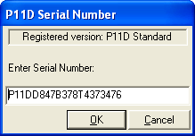

Once again please accept my apologies.

Yours sincerely

Ainol Yaacob
Deloitte & Touche LLP

